

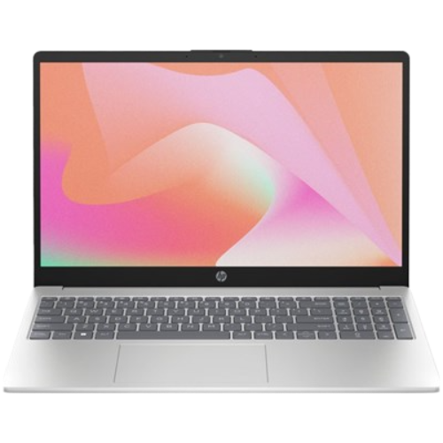

# HP Laptop 15-FD0336NIA

• Intel® Core™ i3-1315U, 6C - Intel® integrated SoC

• 4 GB DDR4-3200 MHz RAM, 256 GB PCIe® NVMe™

M.2 SSD

• Intel® UHD Graphics

• 15.6" FHD Display, FreeDOS 3.0, Backlit KB